Construction manual WIO_Control.

Wireless remote controller with WIFI.

Useable for all digital train control systems via Rocrail.

July 16, 2022

Deventer , The Netherlands.

By Peter Giling.

Copyright:
Giling Computer Applications
The Netherlands
Any copying of this manual is strictly forbidden.

1. Partslist.

Giling Computer Applications supplies a full kit with all parts needed to construct this device.
The partslist is included in the package as listed here:
1 | R1 | resistor 100 KOhm 1/8 watt
1 | R2 | resistor 100 KOhm 1/8 watt
1 | RP1 | Resistor array 8 x100 KOhm SIL9
1 | U1 | Lolin D32 1.1 LED
1 | USB1 | usb-b socket
6 | F0..F5 | pushbutton 13 mm (type 3301) 13mm
1 | DISP1 | I2C oled
4 |  | pcb support M3 x 6 mm
4 |  | fasteners M3 x 6
1 |  | Incremental switch
1 |  | knob 6 x 16 mm
1 |  | housing 2094
1 |  | Pcb WIO_Ctrl
1 |  | frontpanel
2 |  | Supporta M2 x 5
2 |  | Fasteners M2
2 |  | Nut M2

Before starting any job on this unit, please chack the presence of all items in this list.

BEFORE YOU START, READ THESE IMPORTANT NOTES:

- For a proper soldering job, you will need a temperature controlled soldering tool.
- Be sure to take care for a suitable ventilation during this job.
- Without the impropriate (and expensive) tools it is very difficult to remove any soldered part, without destroying part and/or pcb
- Therefore always double check each inserted part on position, before soldering ONE pin .
- Then. check again, and if correct solder all pins.

GCA cannot be hold responsible for any mistake and/or damage in these cases.

2. The housing.
It is important to recognise top and bottom of the box. This picture makes that clear.

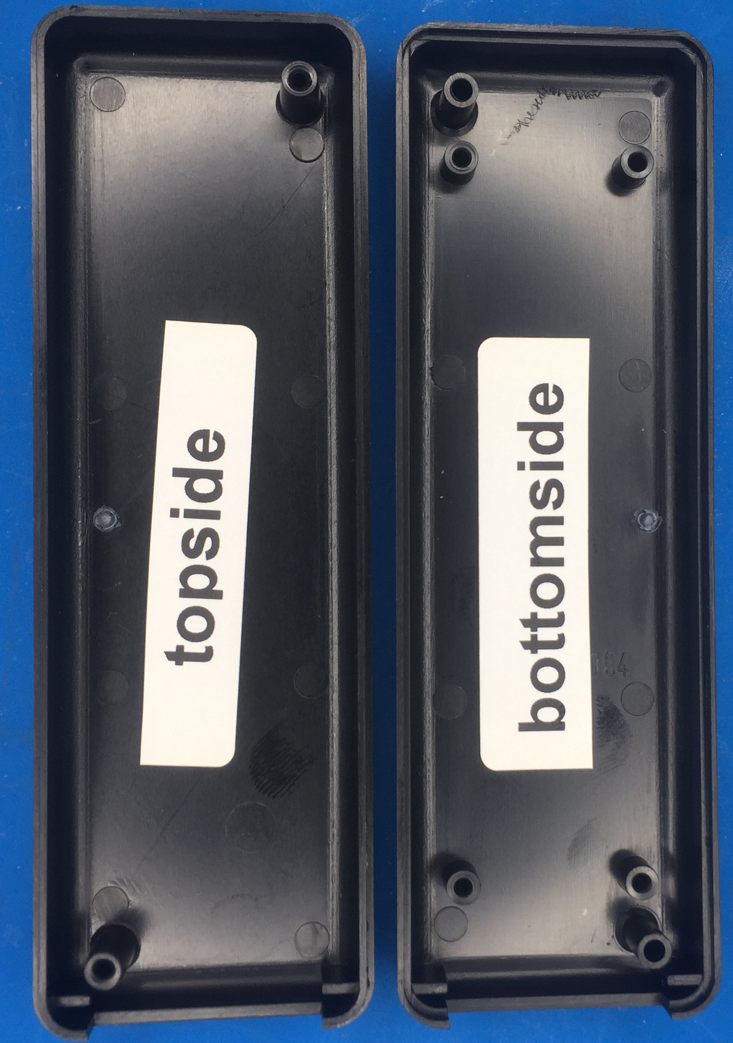
The bottom has 4 support points to fix the pcb.

3. The first drilling job.

Drilling the holes for 6 buttons and incremental switch.
Take the topside and insert the WIO_Ctrl pcb temporary like this picture.
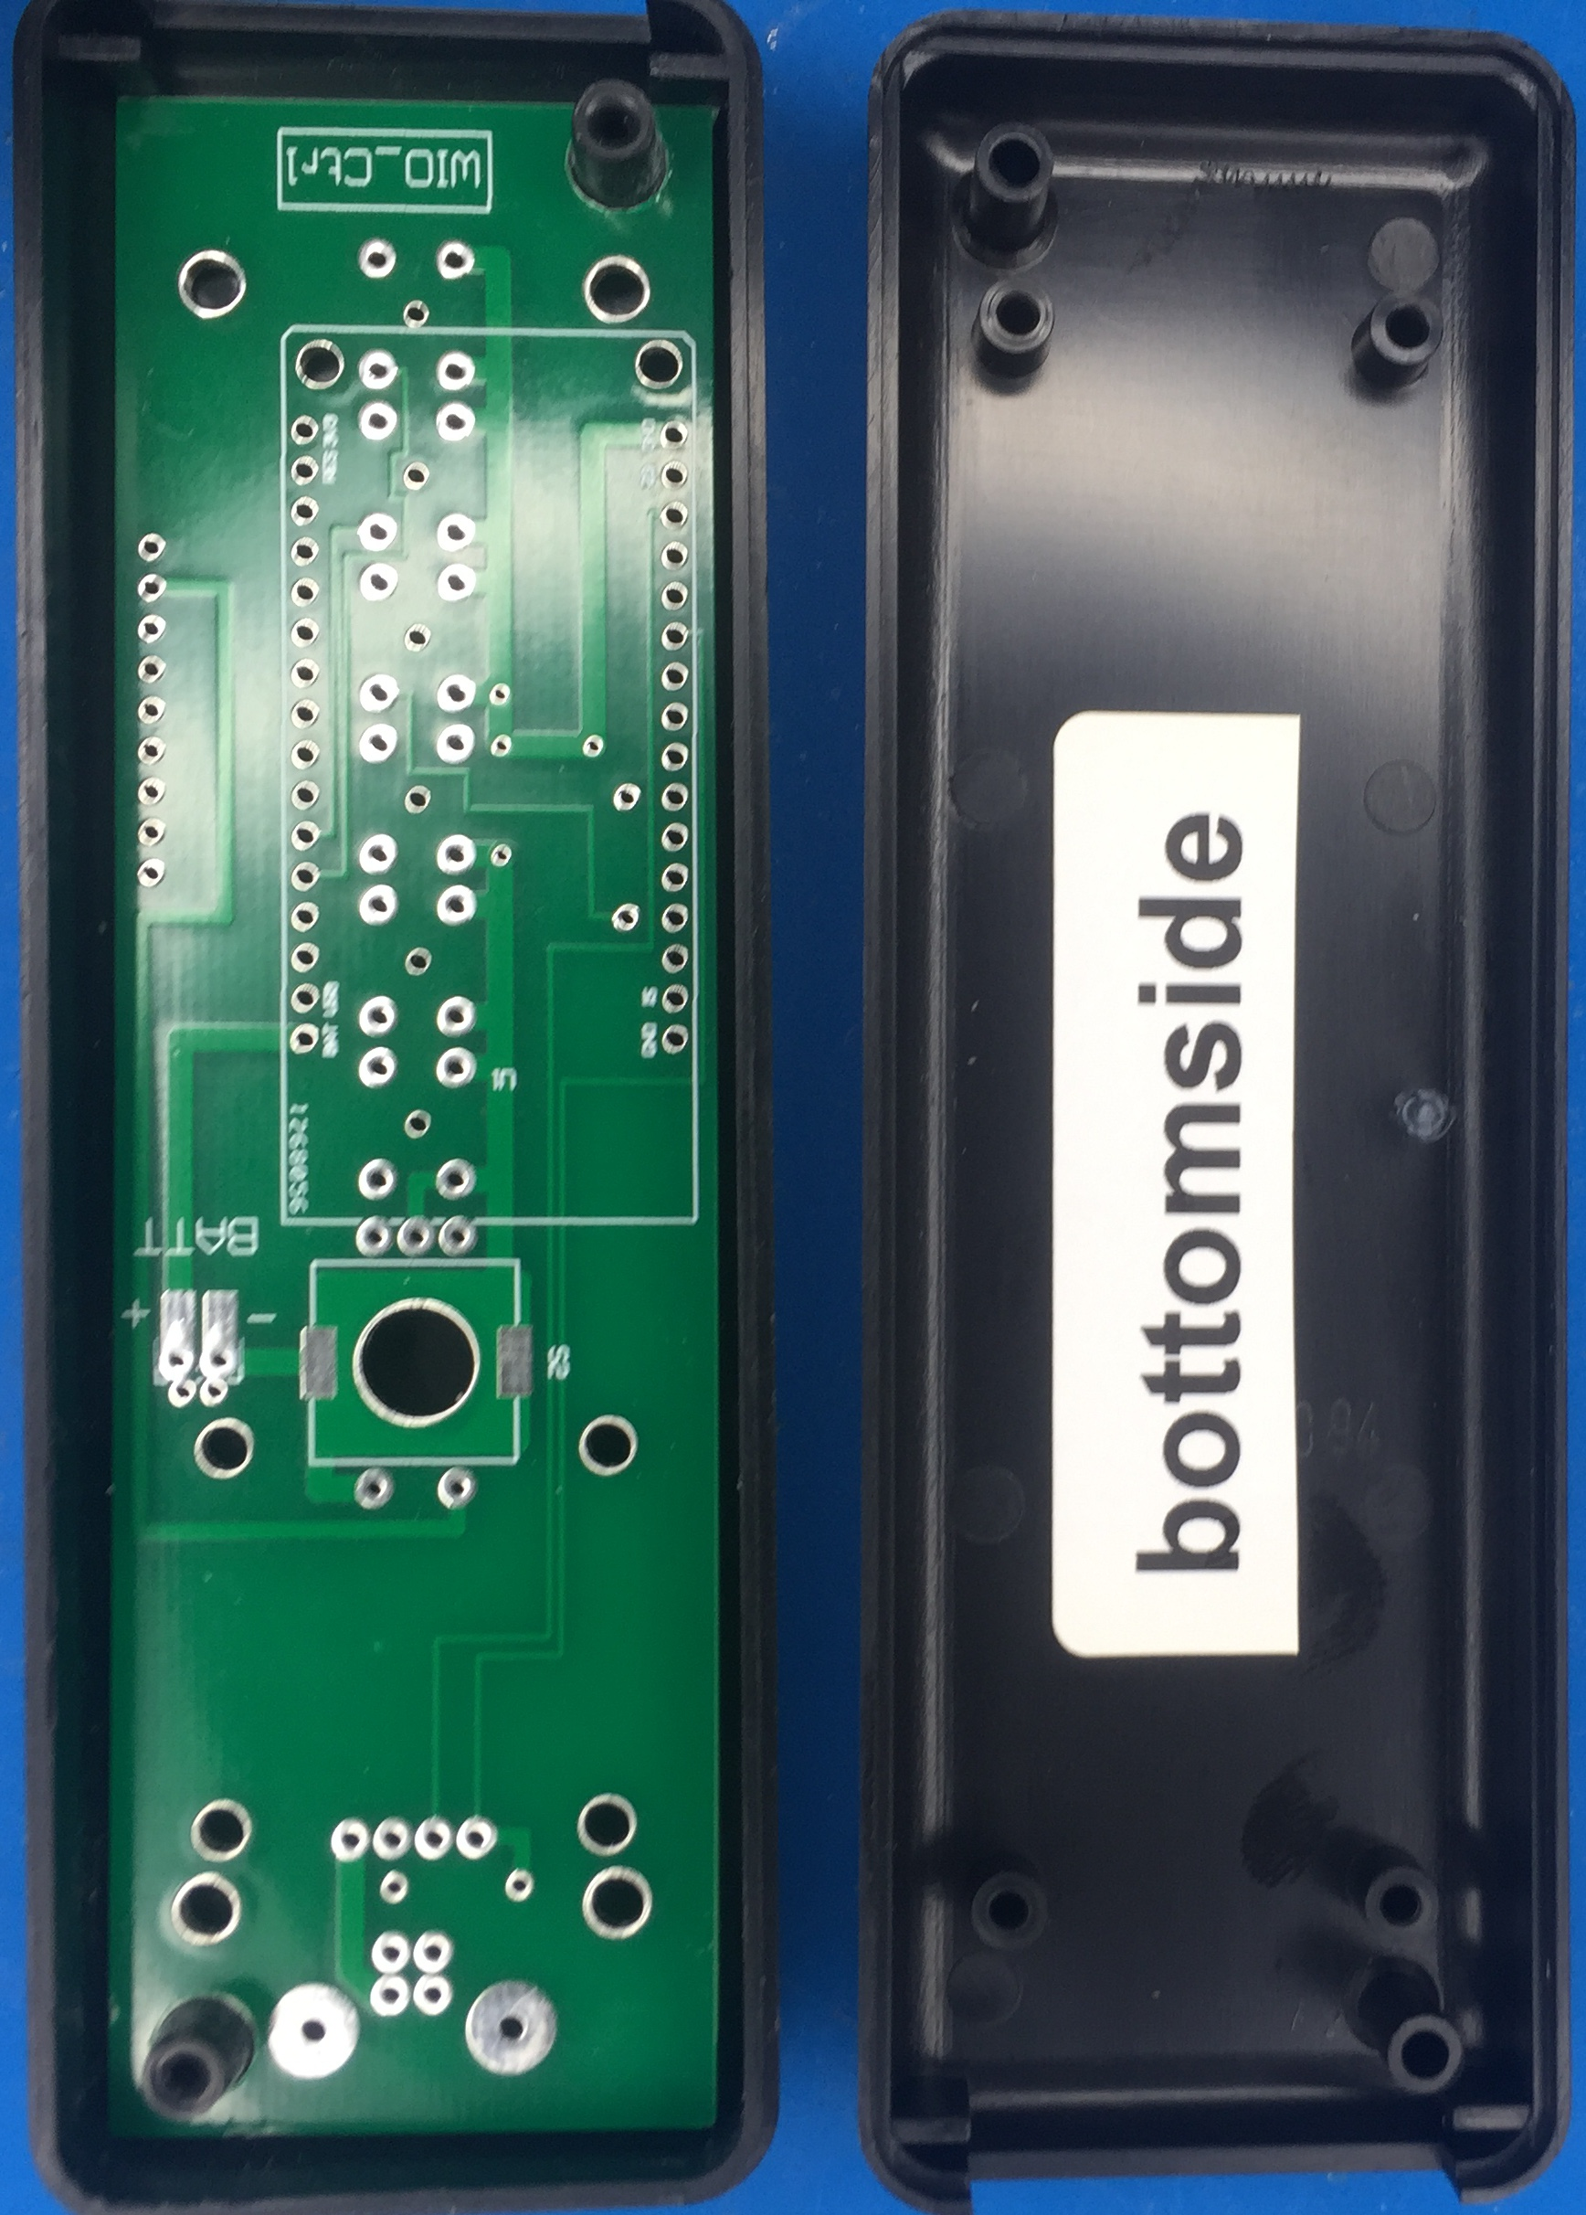
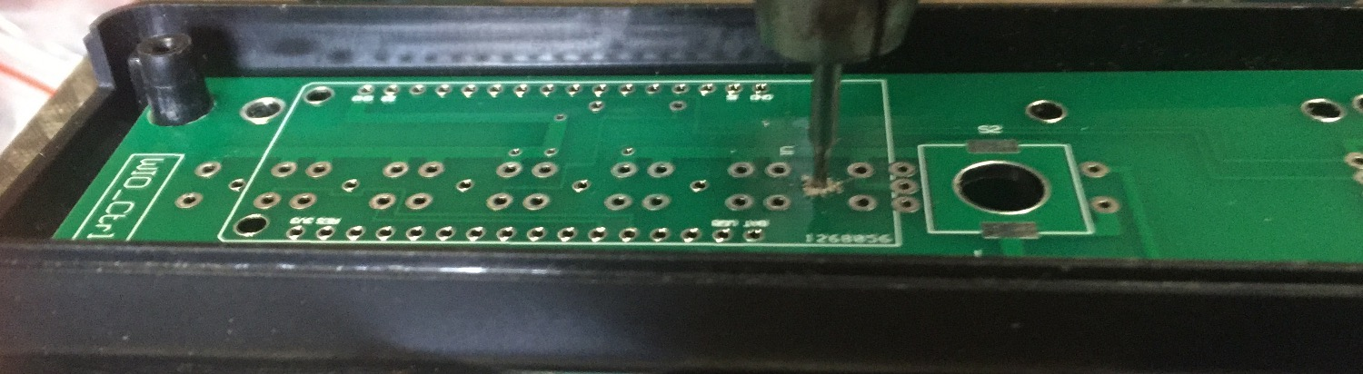
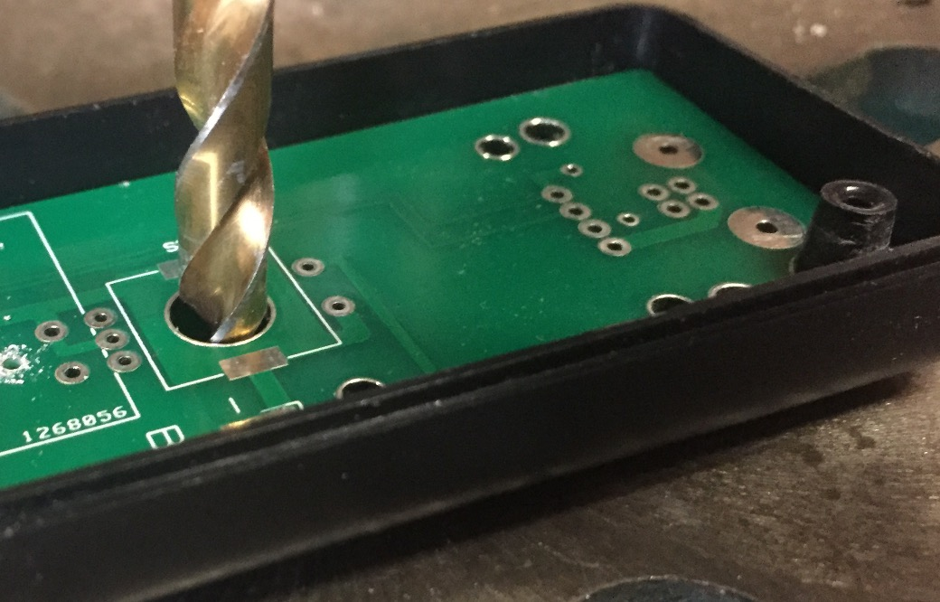
The board fits exactly and will remain in positions this way.
Each pushbutton has one (further unused) central hole, of 1 mm the can be used as a mould to drill a 1mm hole through the ABS material.
Do not forget anyone of the 6 holes.
Then with 7 mm drill, finish the last hole for the incrementsl switch.
Take out the pcb, turn the lid upside down and drill all 6 holes very carefully first with a 2.5 or 3mm drill, and after that with a 5mm drill.

Be sure to drill very gently, do not press the drill because it will cut itself right through, leaving an ugly hole.
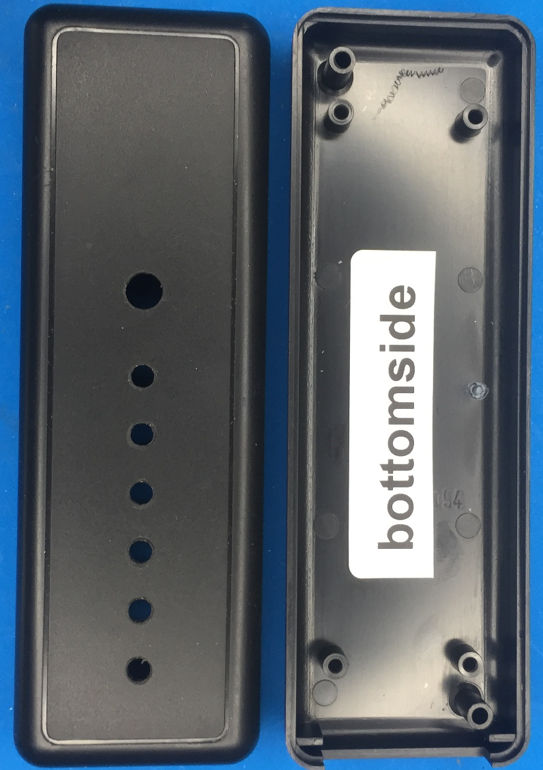

4. Assembling the top of WIO_Ctrl board.

Position of all parts are clearly visible on the pcb.
Be aware that 3 parts are to be positioned at the backside: Incremental switch, LOLIN D32 and usb socket.
-fix resistors 1 and R2 on the right spot, cut the wires at the other side of the pcb and solder them.
Keep these pieces of wire! we will need them later on.
-Fix RP1 and line up the dot mark on the array and on the pcb. Solder that one too.
The 6 buttons should be inserted in such a way that all buttons are postioned nicely in line and vertical parallel with one another. One help can be the supplied front panel,. Just lay it over the buttons and press firmly one different places to be sure all buttons are in line and flat on sourface.
Solder one pin of each button, and check the line up again. In this stage there is still some correction possible.
Double check this buttons before soldering the other 3 pins. After that any correction is rather impossible.
There is still one part missing at this side, the display.
That will be mounted later on.
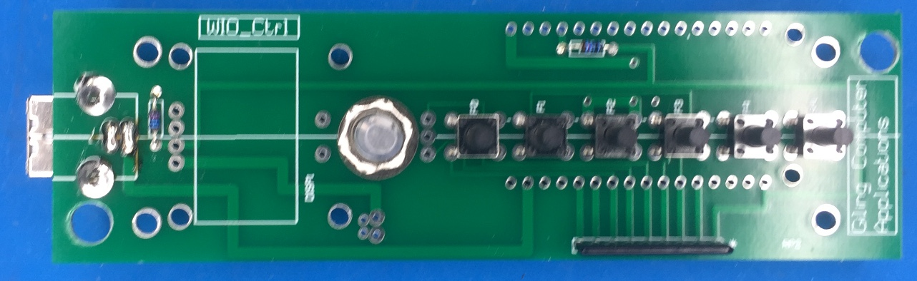
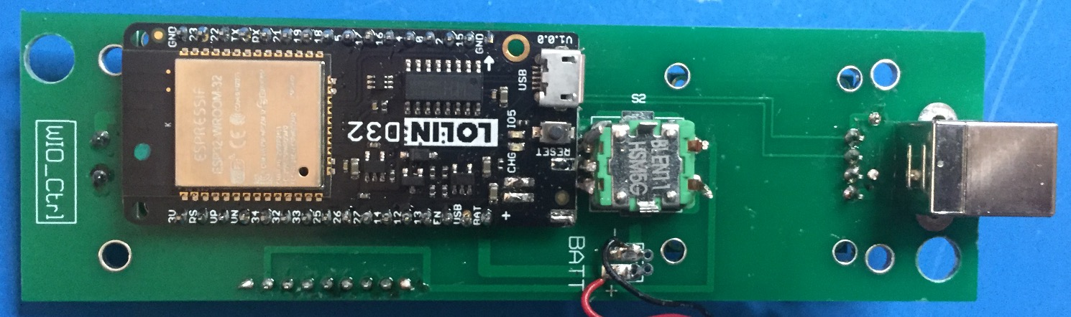

5. Assembling the bottom of WIO_Ctrl board.
The three remaining parts at the bottom need some extra attention.
First double check the soldering job so far.
When things are not correctly soldered or there are short circuits between soldering points, most keys can not be corrected after Lolin has been fixed.
SO, DOUBLE CHECK! And again!
Now the Lolin is mounted like on picture above, and be sure it is inserted as close to pcb as possible.
Since we also need space for the batterie, thee is no other option for this mounting.
Once Lolin is fixed, it is hardly impossible to remove again, without damaging either board or Lolin or even both.
Also here, double check the position like shown on picture p5.
It also fits in a 180° turned postion, so be careful!
That will not work!.
The incremental switch is mounted also.
Unfortunately, this switch is hard to get with pins pointing the other way, so we have to make connections with 5 wires. Bending the pins is no option, they will break off ! So use the small pieces of wires you cut from the resistors.

6.Assembling the display.

Display comes with soldered connector, so there is no other option then to fix it straight into the pcb.
First fix display with two supports M2.
The fasteners should on the display side, and two nuts at the bottomside.
Wenn display lays nicely in line with board, solder the pins.

